**Bug Report for Login**

**BugID: DRZ_001**

**Title:**  
*User tries to login without entering nay credentials in the field and the system does not generates any error message on click of the login button.*

**Reported By:**  
*Faraan Aleem*

**Date Reported:**  
*14/3/2025*

**Environment:**

* **OS:**Windows 10
* **Browser:** *Chrome v95*

**Description:**

*When the user clicks the login button without filling in any fields, no error message is displayed indicating that the fields are empty. The fields should display a message prompting the user to enter information.*

**Steps to Reproduce:**

1. *Go to login page.*
2. *Leave both fields blank.*
3. *Click "Login."*

**Expected Result:**  
*Error message appears ("Please fill the fields").*

**Actual Result:**  
*No error message occurs*

**Screenshots/Screen Recording:**

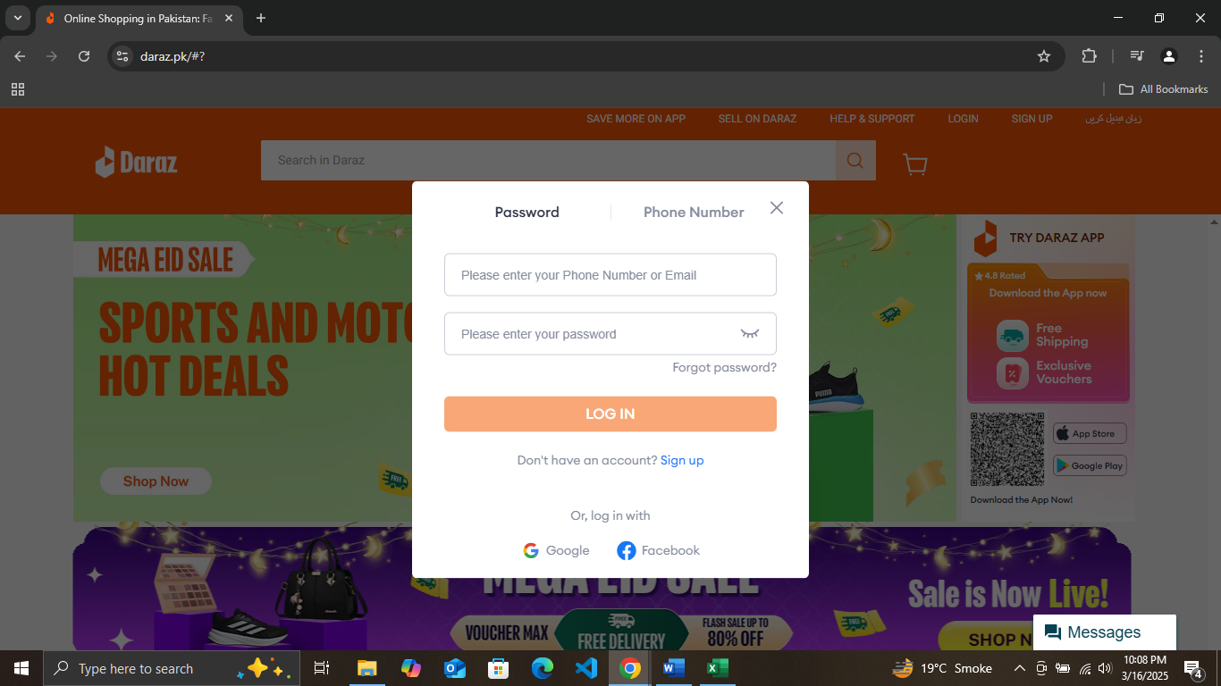

|  |  |
| --- | --- |
| **Severity** | Low |
| Priority | Medium |